AM, GM and HM
mean | two numbers (a,b) | three number (a,b c) | four numbers  (a to d)
AM (arithmetic) | 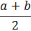 | 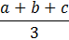 | 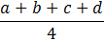 | and so on for upto “n” number
GM (geometric) | 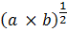 | 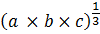 | 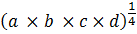 | and so on for upto “n” number
HM (Harmonic) | 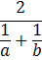 | 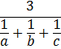 | 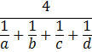 | and so on for upto “n” number

Properties (theory for MCQs)

Geometric Mean
- Geometric mean cannot be calculated if any observation has zero or negative value. Because
  - zero multiplied with any number= zero
  - we cannot find root of a negative number
- Geometric mean always less than arithmetic mean. (except when all observations are same e.g. 5,5,5,5)
- Best for estimating growth and decay related to socio-economic data.
- Geometric mean best for index numbers and when small items need to be given large weight.
- can be solved using logarithms

Harmonic mean
- Harmonic mean is best for finding average speed of vehicle, or average rate of production and certain physics related problems.

